Meeting minutes

Seed ideas
First thing we have to make sure is find out

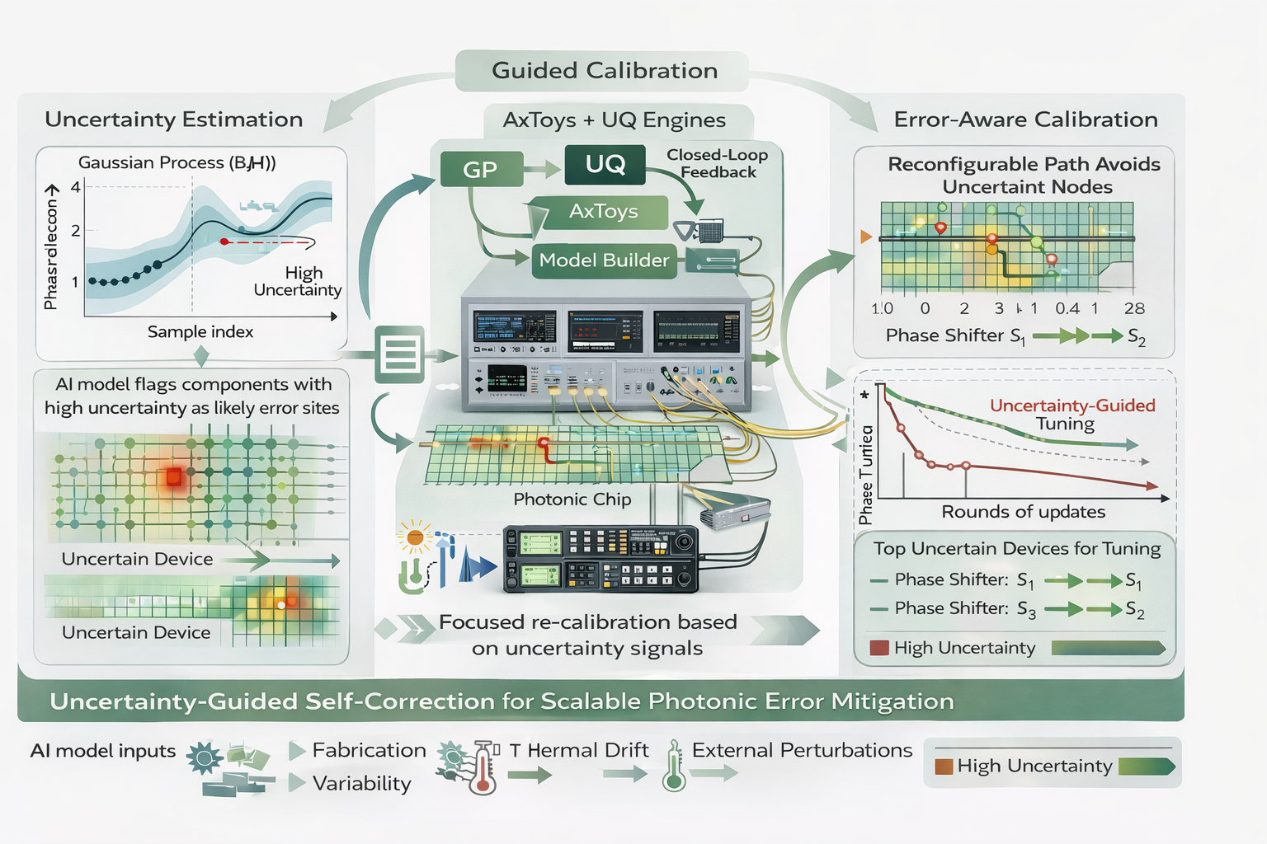

Mathematical Framing of Error Accumulation in MZI Meshes

We treat a mesh of Mach--Zehnder interferometers (MZIs) as a composition of noisy
 unitary operators. Suppose each ideal MZI applies the transformation
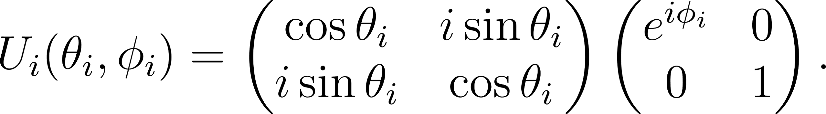

When assembled in a universal mesh, the full circuit implements a target transformation  via 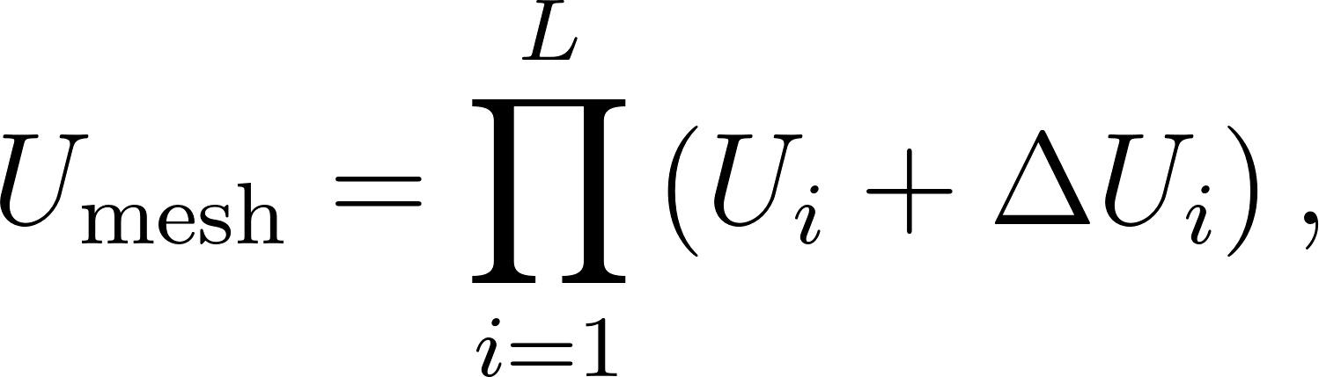 where  represents perturbations arising from fabrication disorder,
thermal noise, or control error (e.g., 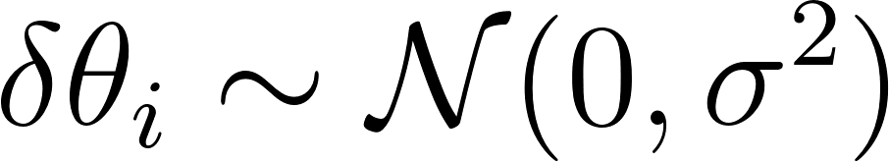).

Key Mathematical Challenge We must understand how these perturbations accumulate in the operator norm or spectral distance, 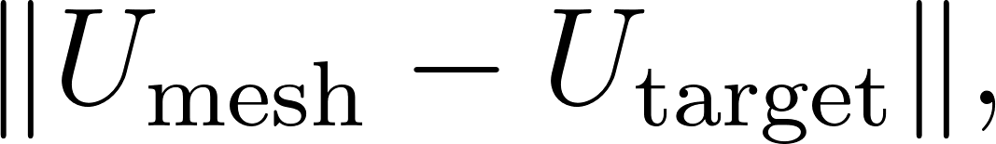 and under what conditions the overall mesh becomes ill-conditioned, for example when the condition number 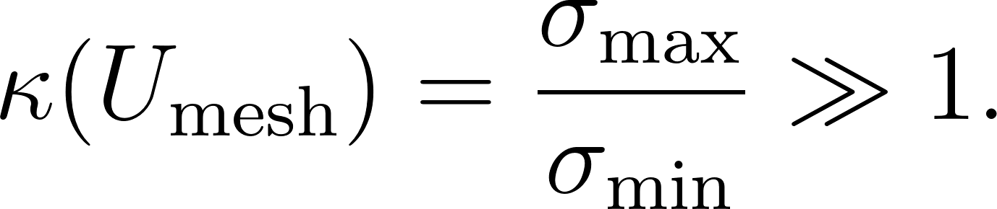

Random Matrix Theory Perspective

If phase-shifter noise is independent and zero-mean, each perturbation can be
modeled as a small random Hermitian matrix,
The full mesh can then be written as
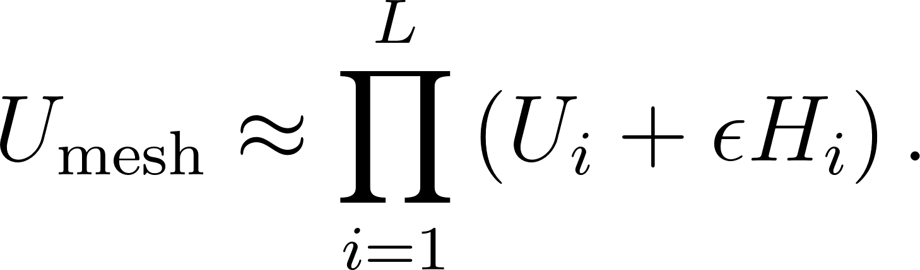 Using first-order perturbation theory,
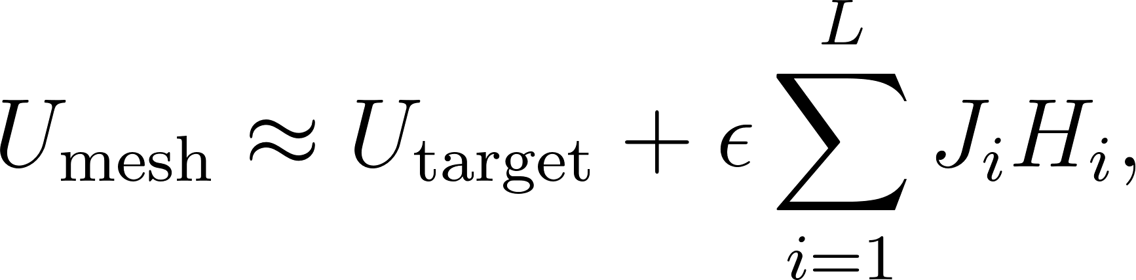 where  are Jacobian-like sensitivity operators that encode how local errors propagate through the mesh. Under suitable assumptions on the statistics of , the ensemble of perturbed
circuits can be modeled as a non-Hermitian random matrix.

Metrics of Interest This framework allows analysis of:
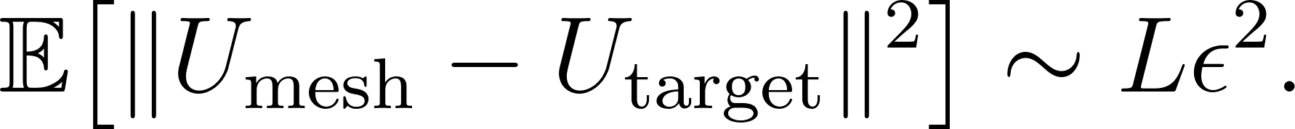 Fidelity loss
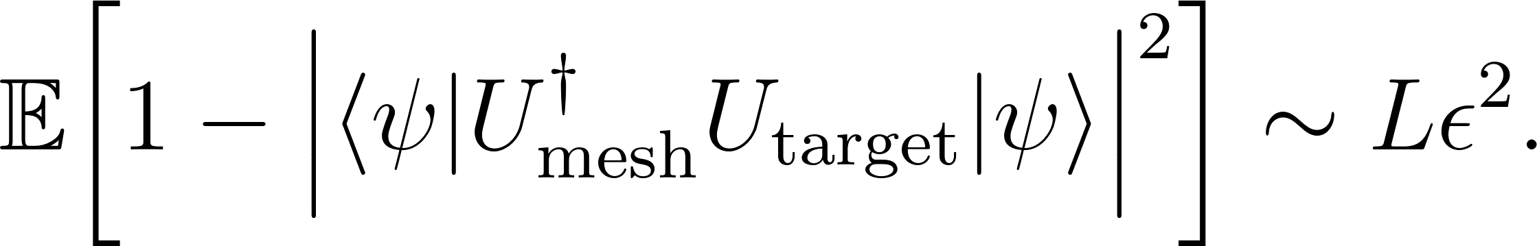

Condition number statistics using tools from random matrix theory, such as the Marchenko--Pastur law for singular value distributions. Implications for Scalable Photonics (DARPA PICASSO) This analysis enables predictive scaling laws,
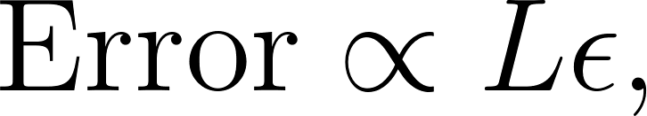 allowing performance bounds to be estimated prior to fabrication. It also supports design optimization, where mesh topologies or reparameterizations  are chosen to minimize spectral sensitivity, and provides analytic guidance for AI-driven layout generation, surrogate modeling, and calibration without requiring full electromagnetic simulation at each design iteration.

How Experimental Data Helps in Scalable Photonic Meshes
1. Empirical Calibration of Component Errors
- Each MZI in a mesh introduces imperfections—e.g., phase bias, thermal drift, or fabrication asymmetry.
- Experimental testbeds provide per-device error profiles, which can be incorporated into simulations or training pipelines for more realistic modeling.
- This enables post-fabrication tuning and error-aware reconfiguration, aligning real hardware with theoretical performance.
2. Surrogate Model Training
- High-fidelity simulations (FDTD, FEM) are expensive. Experimental data provides ground truth to:
  - Train data-driven surrogates (e.g., neural network models of MZI behavior).
  - Quantify nonlinear responses, crosstalk, and temperature dependence that are hard to model from first principles.
- These surrogates allow real-time prediction and control across large graphs of unitary operations.
3. Uncertainty Estimation and Bayesian Updates
- In large meshes, local noise can propagate in unpredictable ways.
- Experimental measurements let us:
  - Estimate posterior distributions over unitary parameters.
  - Apply Bayesian filtering to localize noise sources (e.g., variational inference over phase noise across rows/columns).
- This helps in selective error correction rather than global brute-force tuning.
4. Mesh-Wide Consistency Checks
- When using structured meshes (e.g., Haar or butterfly-like architectures), global measurement data helps:
  - Detect unitarity violations.
  - Enforce row/column orthogonality constraints during runtime.
- Experimental data supports low-rank recovery or compressed sensing techniques for debugging.
5. Design-for-Measurement
- Data from early test-chips helps shape future meshes:
  - By selecting robust MZI topologies less sensitive to phase noise.
  - By embedding diagnostic ports or loopback paths that enhance observability.

